The Dog and his reflection - Aesop's Fables
Aesop's Fables has a large number of stories and some of them such as the Red riding hood, the honest woodcutter and many more are well known across the world. The story of the "The Dog and his reflection" also has other names and is called as "The greedy dog and his reflection" or "The greedy dog". It is the story of a very greedy dog who has a bone and sees that his reflection has a bone as well which angers it.
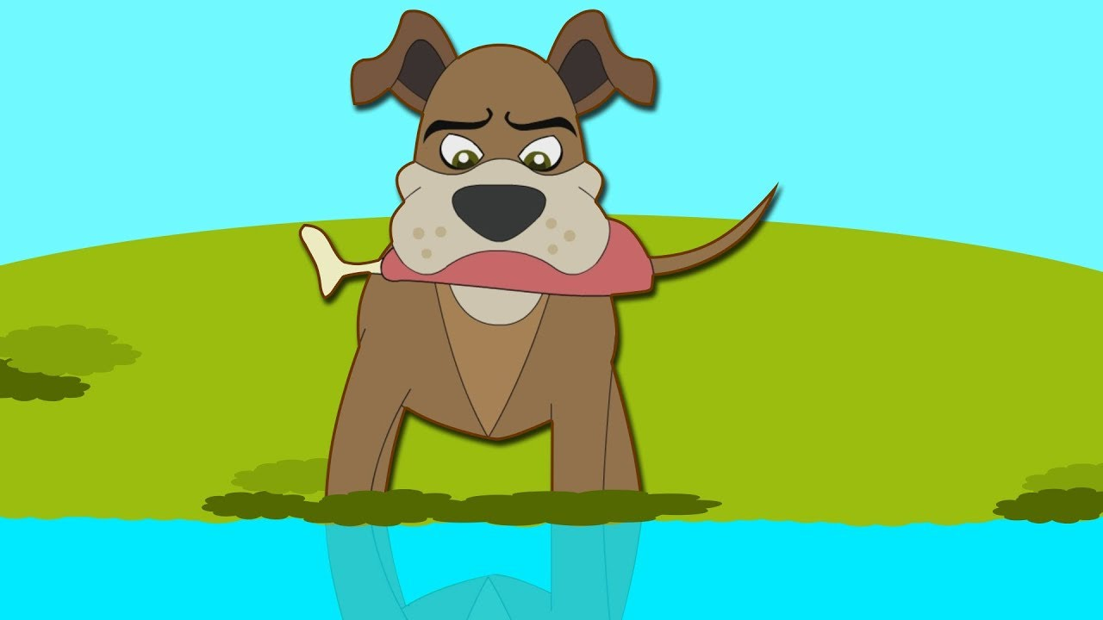
Story:
Once upon a time, there was a dog who lived in the village. He was a very happy dog but he was very greedy.
One day he found a large bone on the road. He was so happy.
The dog said, “Look. Such a lovely bone! It is so big and juicy. I shall feast on it today.”
The dog picked up the bone and started walking towards the forest. He was crossing a bridge which had very still water beneath. The water reflected like a mirror and what did he see? He saw himself, a dog holding a bone.
But the dog was very greedy. It looked as if the dog below was carrying a much bigger bone.
He thought, “How can another dog have a bigger bone than me”.
He snarled. In the reflection, he saw a dog snarling back. He raised his paws angrily. In the reflection, he saw a dog raising the paws angrily.
He thought, “How can another dog snarl at me. How can another dog raise its paws at me”
Thinking in anger, he jumped into the water and found no dog. He had to swim for his dear life. He scrambled out but lost the bone. He finally realized how stupid he had been and how greedy he had been.

What is the moral of the story?
The moral of the story "The Dog and his reflection" is “It is very foolish to be greedy.”. An alternative moral is "Think twice before you act".

Other stories which you can read
The Dog and the Hides
The Cock, The Dog and the Fox
The Farmer and the Snake
The Farmer and the Stork
The Cat and the Birds

Questions on "The Dog and his reflection"
- Who are the main characters of the story?
- What did the dog find on the road?
- What made the dog very angry?
- What happens at the end of the story to the greedy dog?
- Explain is the moral of the story?

Answers:
- The main character of the story is a Dog
- One day he found a large bone on the road. He was so happy.
- The dog was crossing a bridge and water reflected like a mirror. He saw himself, a dog holding a bone which angered him very much as he was very greedy. It looked as if the dog below was carrying a much bigger bone.
- The dog jumped into the water and lost the bone. The dog then realized how stupid he had been and how greedy he had been.
- The moral of the story “It is very foolish to be greedy.”. An alternative moral is "Think twice before you act".

